**What happened in the 2006 Palestine election?**

**Lesson 14**

**By the end of this lesson, you should be able to:**

Describe Hamas

Explain the results of the 2006 election

Discuss the response to the election results

**Keywords**

2006 Palestine election

Hamas

Ismail Haniyeh

Izz al-Din al-Qassam Brigades

**Knowledge check!**

1)What is occupation?

2)What do you already know about living conditions under occupation?

3)What can you remember about Palestinian nationalism, specifically Yasser Arafat and Fatah?

**The Annexation of Jerusalem**

In 1980, Israel passed the **Jerusalem Law** which meant that it illegally annexed (forcibly acquired) East Jerusalem. This was condemned by the UN in UN Security Council Resolution 478 of 1980

**Hamas**

When learning about the 2006 Palestine election, we need to look at Hamas

H.A.M.A.S (Hamas) is an acronym of Harakat al-Muqawama al-Islamiyya (Arabic for ‘Islamic Resistance Movement’ and ‘zeal’ = energy/enthusiasm). It is an **Islamic Palestinian nationalist party** which was established in 1987

It has been deemed a terror organisation by Israel, the United States and the European Union

**Establishment and ideology**

At first, Hamas saw all Jews as its enemies, wanted to rule all of historic Palestine-Israel and called for the destruction of Israel

However, this seems to have changed now. In 2007, Hamas described all **Zionists** rather than all Jews as its enemies. It also said that it would accept a state of Palestine along the **1967 borders**. This was reaffirmed in the new Hamas Charter of 2017

But Hamas has **still not recognised Israel**

**Questions**

1.What is antisemitism?

2.What is the difference between being Jewish and being a Zionist?

3.What are the 1967 borders?

**The rise of Hamas**

Hamas became increasingly popular among Palestinians after 1987.

It had two main activities:

1.The Izz al-Din al-Qassam Brigades, a military wing who pursued armed struggle against Israel

2.An extensive social welfare programme, including orphanages, nurseries, schools, library services, sports clubs, summer camps, soup kitchens, food banks and medical services

Hamas became particularly popular among Palestinians due to its social welfare programme

**Hamas: leadership**

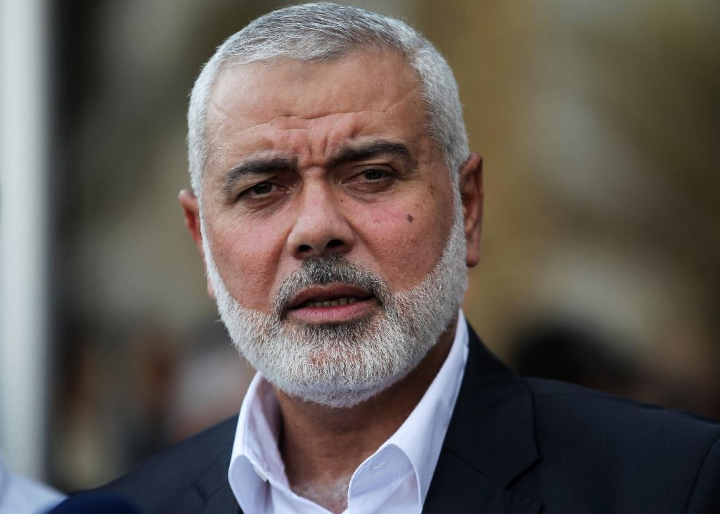

Hamas was led by Sheik Ahmed Yassinfrom 1988 until his assassination by Israel in 2004

It was then led by Abdel Aziz l-Rantissi, who was also assassinated by Israel a month later

Since then, Hamas have kept their leader secret but **Ismail Haniyeh** (pictured) is Hamas’ spokesperson

**Activity**

**Suicide bombings**

Hamas claimed responsibility for many suicide bombings in Israel between 1989 and 2008, particularly in 2002 at the height of the Second Intifada (2000-2005). **In 2002, Hamas claimed responsibility for 19 of the 47 Palestinian suicide bombings that took place in Israel**. Between September 2000 and August 2002, 415Israeli and other citizens were killed as a result of attacks by armed Palestinians, most of them from suicide bombings

Amnesty International and Human Right Watch have deemed these attacks crimes against humanity

**The 2006 Palestine election**

The 2006 Palestine election took place on **25th January 2006**. The two main parties to vote for were Fatah and Hamas (under the name Change and Reform). In the end, **Hamas won the majority of the vote:**

Hamas: 44%

Fatah: 41%

Other parties: 15%

**Question**

Palestine was the first community to have an election under occupation. What does this tell you?

**Why were Hamas elected?**

Hamas were elected for multiple reasons. Some of them are listed here:

1.Palestinians were fed up with living under occupation. As we have seen, life is very difficult under occupation. Palestinian homes were being demolished and illegal Israeli settlements continued to be built on Palestinian land. Palestinians wanted a **change** of government

2.Many Palestinians were impressed with Hamas’s extensive **social welfare programme**

3.Fatah was criticised for focusing **too much on the West Bank** at the expense ofGaza

4.Some Palestinians were also fed up with **corruption** in Fatah

**Questions**

1)What is the definition of **boycott**?

2)Where have we seen an example of boycotting before?

3)Do you know of any examples of boycotts outside Palestine-Israel?

**What was the response?**

Fatah refused to work with Hamas: they were **rivals**!

Israel launched multiple raids on Gaza and the West Bank. By August 2006, Israel had **arrested** almost 50 Hamas officials

The Quartet on the Middle East (the UN, US, EU and Russia) said that unless Hamas recognised Israel and renounced violence, they would not work with it. Hamas refused to do this and so the international community **boycotted** the election result: they withheld important humanitarian aidfrom Palestine

Palestinians felt that this was **unfair**: they had democratically voted Hamas into power

Eventually, Hamas took control of Gaza, and Fatah took control of the West Bank

**Questions**

1)What is Hamas?

2)What were the results of the 2006 election?

3)How did the following respond to the results:

-Fatah

-Israel

-The international community

**Extension activity**

When should democratic decisions be challenged?

1.Read the extracts below from ‘Hamas celebrates election victory’ in *The Guardian*, 26th Jan 2006

A)“Mr Bush said a party that advocated the destruction of Israel would never be partner for peace, but also hailed the result as an example of democracy in action”

B)“…acting Israeli prime minister, said Israel could not trust a Palestinian leadership in which Hamas had a role. ‘Israel can't accept a situation in which Hamas, in its present form as a terror group calling for the destruction of Israel, will be part of the Palestinian Authority without disarming’”

2.Imagine it is 2006 and you are a foreign policy adviser. How would you advise the following respond to the election results?

-Israel

-US

-EU